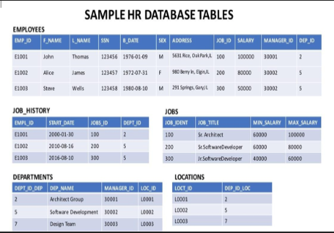

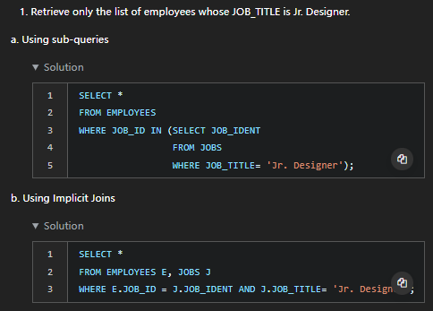

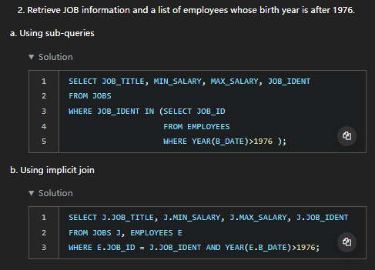

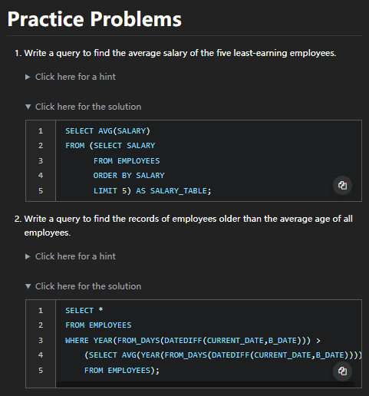



Ii

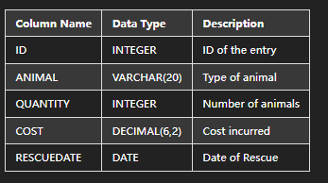

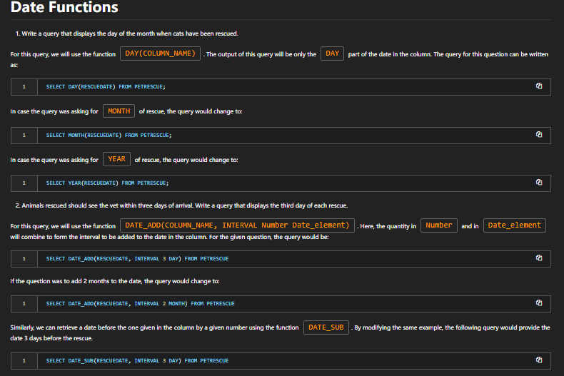

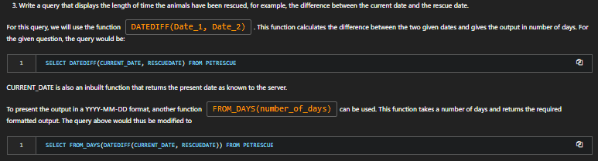

##### Create a scatter plot using the variables per_capita_income_ and hardship_index. Explain the correlation between the two variables

Pip install seaborn

**import** matplotlib.pyplot **as** plt  
**%**matplotlib inline  
**import** seaborn **as** sns  
  
income_vs_hardship **=** **%**sql SELECT per_capita_income_, hardship_index FROM chicago_socioeconomic_data;  
plot **=** sns.jointplot(x**=**'per_capita_income_',y**=**'hardship_index', data**=**income_vs_hardship.DataFrame())